**Homework 6**

**Due: 10/31/2024 by 11:59 PM**

In this assignment, you will create a database called *“movies”*, and then will create 4 tables under it. The names of the tables are as follows; “Actors”, “Directors”, “Movies” and “Movies Revenues”. After creating the database and the tables, you will create several variables under these tables. In the final stage, you will insert data into these tables. Below is the screenshot of the *“movies”* database and the 4 tables under it.

1. So, your first step is to go ahead and create this database called “movies”. As you can see, a sample screenshot from the output is given below. After creating the database, please attach your own output screenshot (just like I did below).

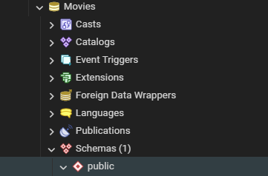

1. Write a SQL query to create the “**actors**” table as well as the related 7 variables. The features of these variables (that should be considered while creating these variables) are provided below. As can be seen, a sample screenshot is given (below) from the “actors” table. (Note that, I have provided couple of rows for you to see what this table will eventually look like. However, you should not insert any data values at this step. You should only create the table with the following variables and that is it.

* **actor_id** has the “serial” type. Note that this column is the primary key of the table.
* **first_ name** and the **last_name** are strings that have the “limited varying character (150 characters)” type.
* Note that the **last_name** cannot take “null” values (constraint)
* **gender** is string that have the “fixed length character (1character)” type.
* **Date_of_birth, add_date** and the **update_date** are date columns that have the “date” type.

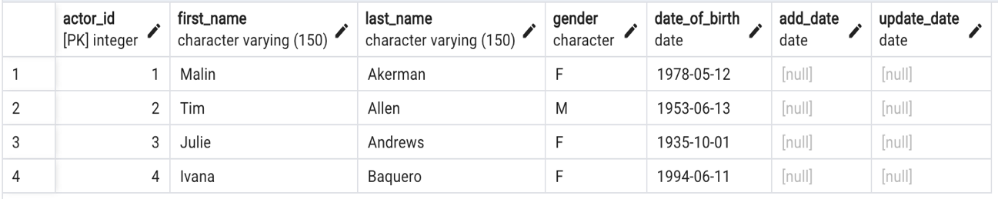

CREATE TABLE actors (

actor_id serial primary key,

first_name varchar(150),

last_name varchar(150) not null,

gender char(1),

date_of_birth date,

add_date date,

update_date date

);

1. Write a SQL query to create the “**directors**” table as well as the related 7 variables. The features of these variables (that should be considered while creating these variables) are provided below. As can be seen, a sample screenshot is given (below) from the “directors” table. (Note that, I have provided couple of rows for you to see what this table will eventually look like. However, you should not insert any data values at this step.

* **director_id** has the “serial” type. Note that this column is the primary key of the table.
* **first_name** and the **last_name** are strings that have the “limited varying character (150 characters)” type.
* **nationality** is string that has the “limited varying character (20 characters)” type.
* **Date_of_birth, add_date** and the **update_date** are date columns that have the “date” type.

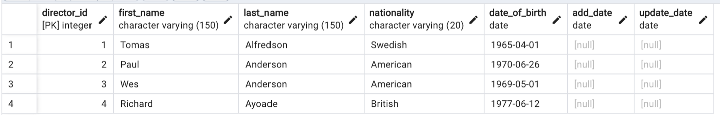

CREATE TABLE directors (

director_id serial primary key,

first_name varchar(150),

last_name varchar(150),

nationality varchar(20),

date_of_birth date,

add_date date,

update_date date

);

1. Write a SQL query to create the “**movies**” table as well as the related 7 variables. The features of these variables (that should be considered while creating these variables) are provided below. As can be seen, a sample screenshot is given (below) from the “movies” table. (Note that, I have provided couple of rows for you to see what this table will eventually look like. However, you should not insert any data values at this step.

* **movie_id** has the “serial” type. Note that this column is the primary key of the table.
* **movie_name** is string that has the “limited varying character (150 characters)” type.
* Note that the **movie_name** cannot take “null” values (constraint)
* **Movie_length** has the “integer” type.
* **movie_lang** is string that has the “limited varying character (20 characters)” type.
* **age_certificate** is string that has the “limited varying character (10 characters)” type.
* **release_date** is a date column that have the “date” type.
* **director_id** has the “integer” type.
* **director_id** is a foreign key that should be referenced to the director_id from the directors table.

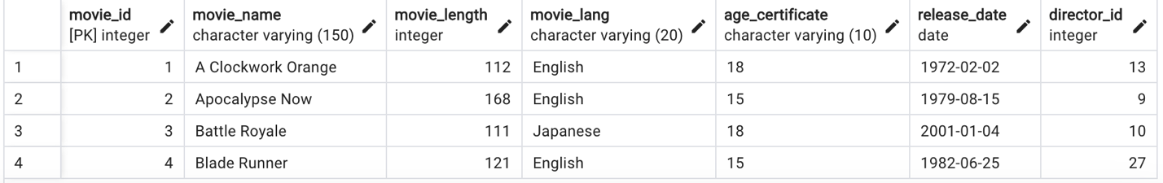

CREATE TABLE movies (

movie_id serial primary key,

movie_name varchar(150) not null,

movie_length int,

movie_lang varchar(20),

age_certificate varchar(10),

release_date date,

director_id int,

foreign key(director_id) references directors(director_id)

);

1. Write a SQL query to create a table called “**movies_revenues**” table as well as the related 4 variables. The features of these variables (that should be considered while creating these variables) are provided below. As can be seen, a sample screenshot is given (below) from the “**movies_revenues**” table. (Note that, I have provided couple of rows for you to see what this table will eventually look like. However, you should not insert any data values at this step.

* **revenue_id** has the “serial” type. Note that this column is the primary key of the table.
* **movie_id** has the “integer” type
* **movie_id** is a foreign key that references to the movie_id from the movies table.
* **Revenues_domestic** and the **revenues_international** are numeric columns that have the “numeric” type that have precision of “10”, and the scale of “2”

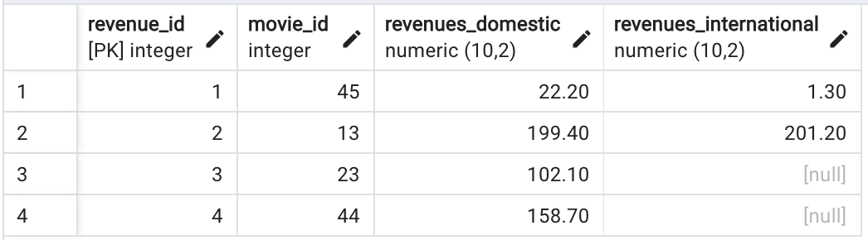

CREATE TABLE movies_revenue (

revenue_id serial primary key,

movie_id int,

revenue_domestic numeric(10,2),

revenue_international numeric(10,2),

foreign key(movie_id) references movies (movie_id)

);

**Now, we will go ahead and insert data into our tables that we have created in the previous steps.**

**At this point, please go ahead and download the sql files/scripts from the “Assignment 6 Data.zip“ folder under module *Week 8*. You will find four(4) sql files such as “movies.sql”, “directors.sql”, “actors.sql”, and “movies_revenues.sql” .**

**Make sure you follow the sequence of inserting data in the order below as we are adding data to tables with foreign_key constraints.**

1. Go ahead and open the “directors.sql” file in your PgAdmin environment and insert the values given in that file into “Directors” table. Then go ahead and make sure that your data is inserted by running;

***SELECT * FROM directors***

***LIMIT 4;***

and provide the screenshot of your output below.

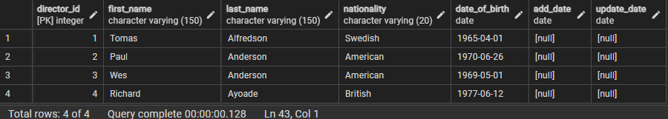

1. Do the same thing for “actors” table.

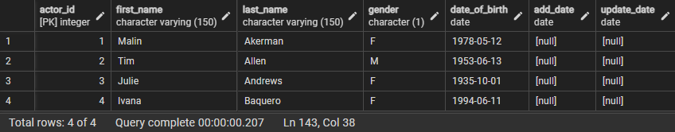

1. Do the same thing for “movies” table.

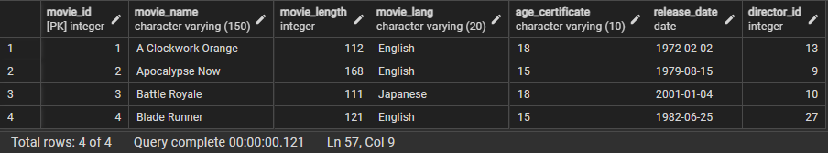

1. Do the same thing for “movies_revenues” table.

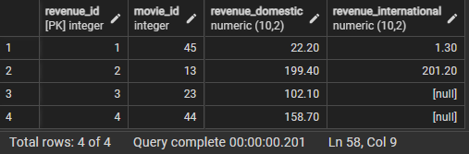

1. By using inner join, retrieve movie_id, movie_name, movie_lang, release_date, revenues_domestic and revenues_international. Save the output of this question as “movies_total” table.

***Use movies_total table for the questions 11, 12, 13 and 14.***

CREATE TABLE movies_total AS

SELECT movie_id, movie_name, movie_lang,release_date, revenue_domestic, revenue_international

from movies

inner join movies_revenue

using(movie_id);

1. Find the total domestic revenue amount for movies with “English” language.

select sum(revenue_domestic) as total_revenue_domestic

from movies_total

where movie_lang = 'English';

1. Replace the NULL values in the revenues_domestic column with **30**.

update movies_total

set revenue_domestic = 30

where revenue_domestic is null;

1. Add a NOT NULL constraint for revenues_domestic column.

alter table movies_total

alter column revenue_domestic set not null;

1. Add a DEFAULT value of **50 for** revenues_international column and show that default value is working by inserting a record to the movies_total table.

alter table movies_total

alter column revenue_international set default 50;

INSERT INTO movies_total (movie_id, movie_name,movie_lang,release_date,revenue_domestic) VALUES

(67,'Leo', 'Tamil', '2023-10-23', 100);

select * from movies_total

where movie_id = 67;

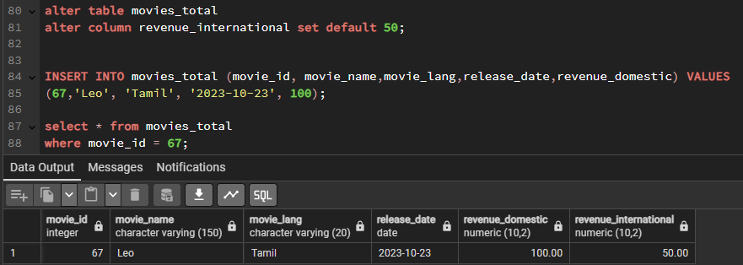

1. Attempt to update the **director_id** from 27 to 44 in the **directors** table. Describe the type of output you receive upon trying to update the **director_id** in the **directors** table. What should have been done to avoid the error encountered? (Note: You don’t have to recreate the **directors** table. Just explain the solution that allows us to update the **director_id** in the **directors** table.)

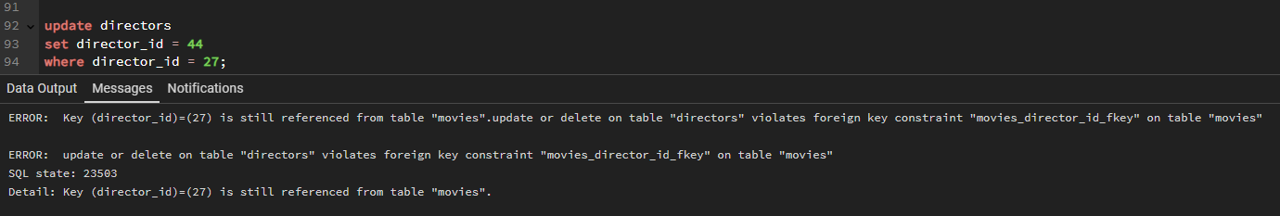

We got this error because director_id in directors table is referenced as a foreign key in movies table.

This update violates foreign key constraint on movies table.

To solve this issue we have to define the foreign key with ‘On update cascade’ constraint. This constraint will automatically update the values in the foreign key of the child table when the primary key of the parent table is updated.